Git challenges
- Resolve Merge Conflicts
  - Create a merge conflict intentionally (two users editing the same line).
  - Resolve the conflict and push the changes.
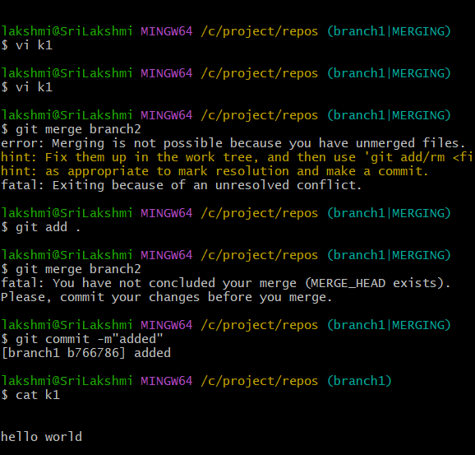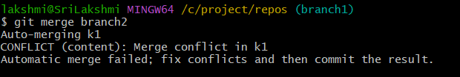
Touch k1 – create file
Git add . – add the file to central repo
Git commit m “message” – commit the message
Switch branch – switch the branch
Again same name with same and same content
Touch k2 / git add . / git commit
Git merge branch 2 – by using merge combined the 2 branch
Git push
and see in repo

2.Recover Deleted Branch

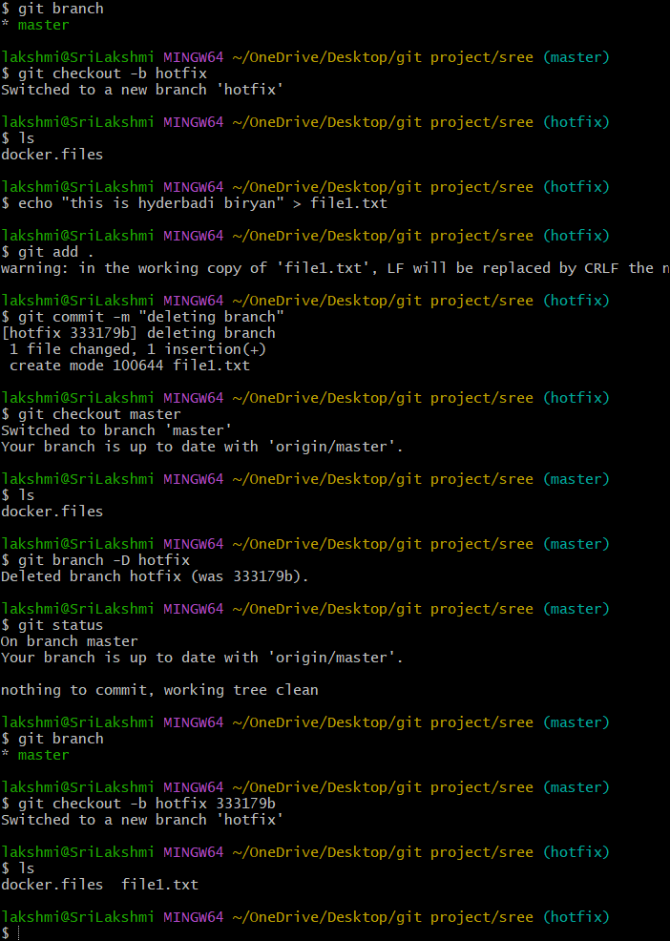
Git branch -d - delete the branch but stops if it is not fully merged
Git branch -D – forcefully deleted a branch even if it in merged or not
Git checkout -b hotflix <commitid> - now we recovery the delete branch

3.Undo Wrong Push
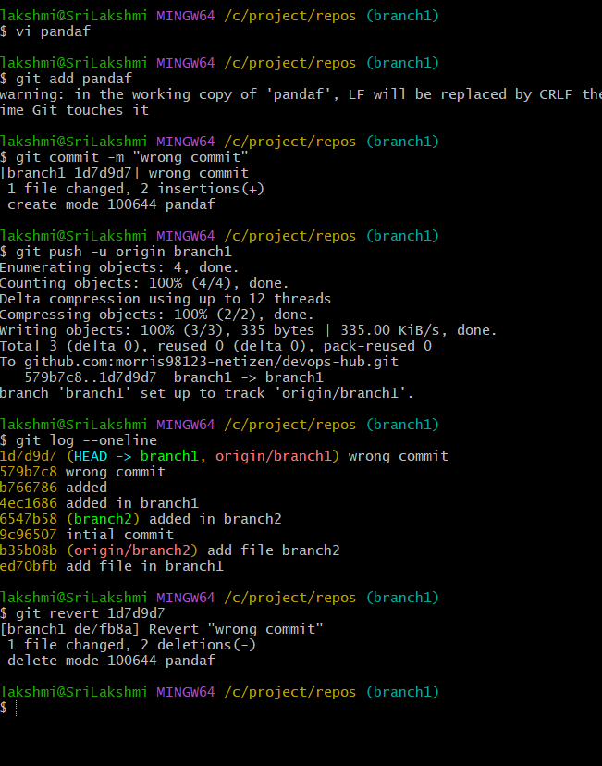
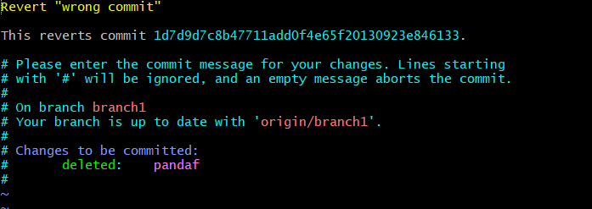
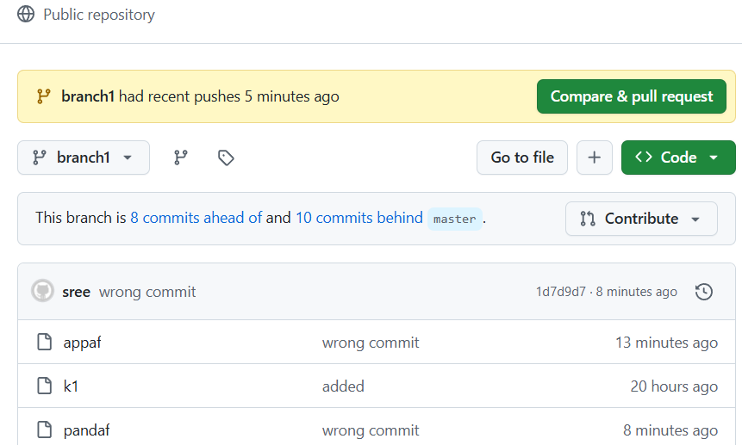

Vi pandf - create a file
Git add .
Git commit -m
Git log –oneline
Git revert < commit id > - take the commit
Then check in repo for pandf file with is present in repo

4. Amend a Commit
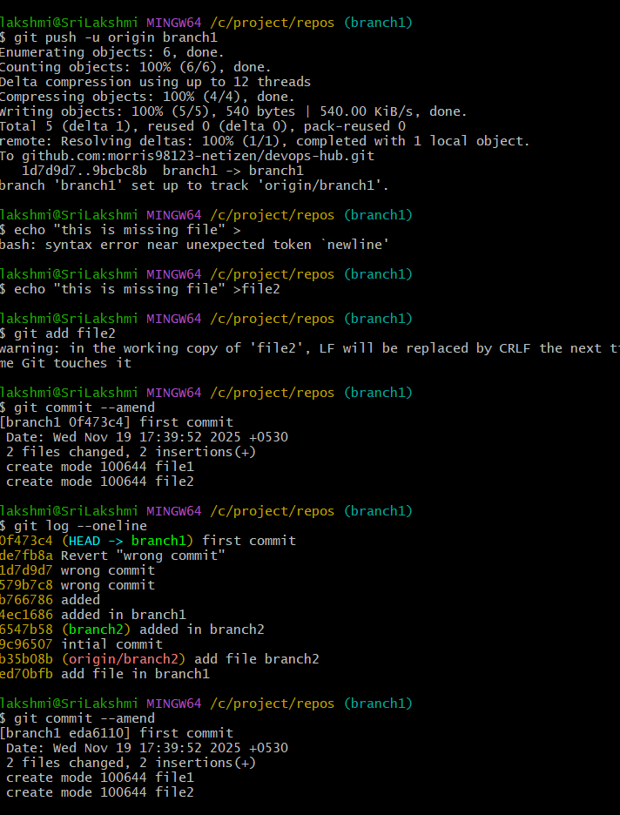
Echo “hello”>file1 – it is used to create and edit the content
Git add file1
Git commit -m
Git push -u origin branch1
Echo “missing file”>file2
Git add file2
Git commit –amend
Git log –oneline
If the commit is already pushed then you must force-push
Git push –froce

5. Cherry-pick a Commit
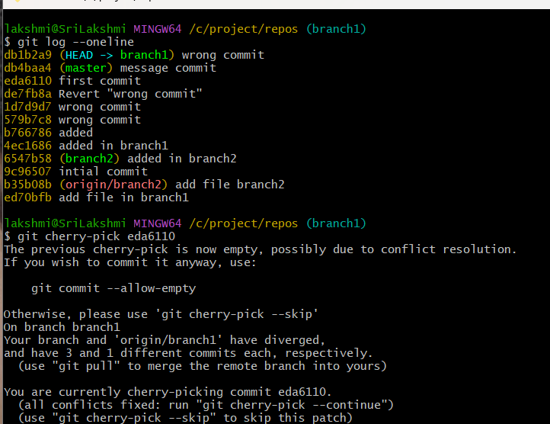
Git checkout < branh1>
Git checkout <matser >
Git log –oneline
Git cherry-pick <commit id>

6. Interactive Rebase
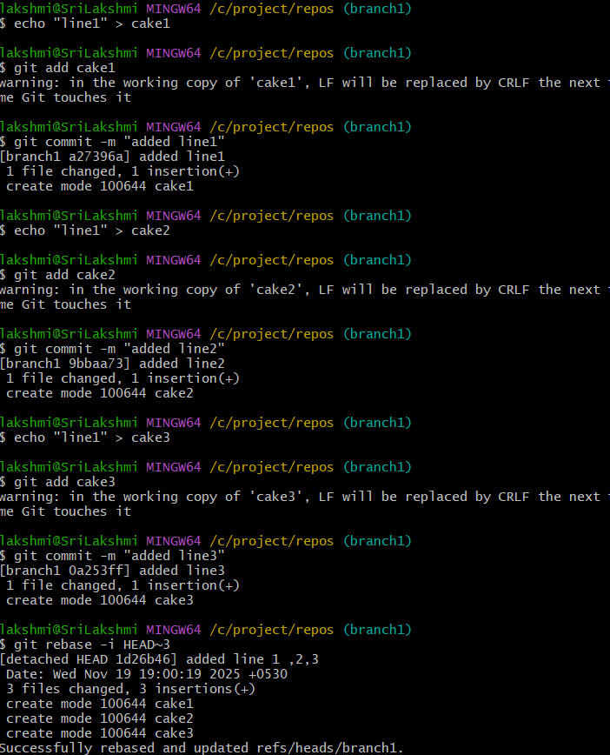
Create 3 new files and add /commit /
Git rebase -I HEAD~3
Git push
See the file in repo

7. Tagging & Release
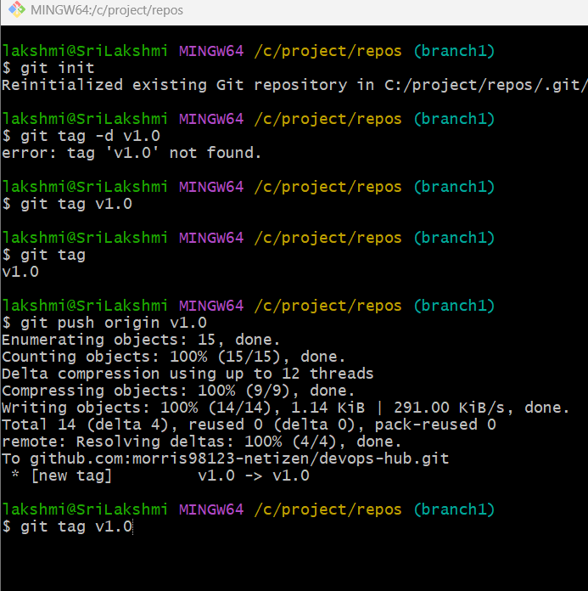
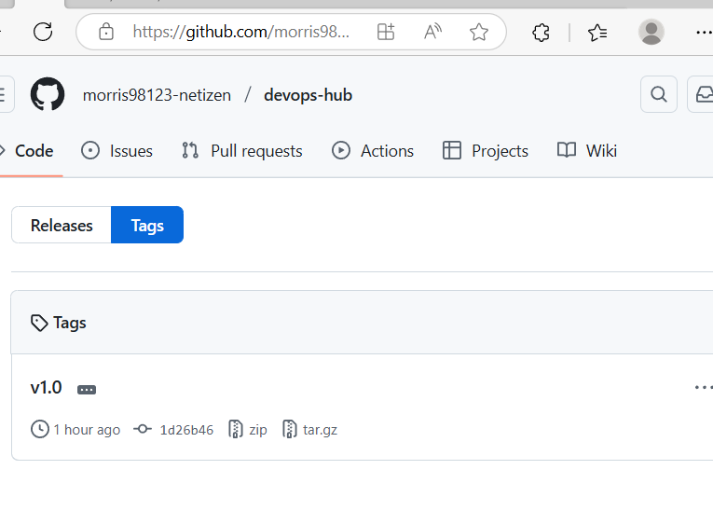

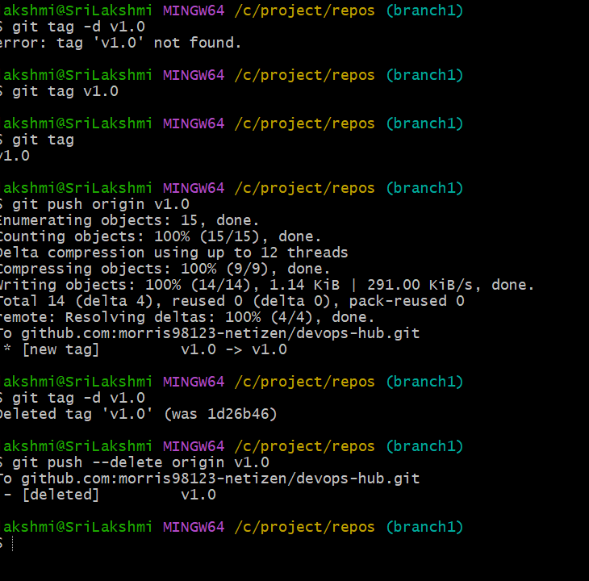
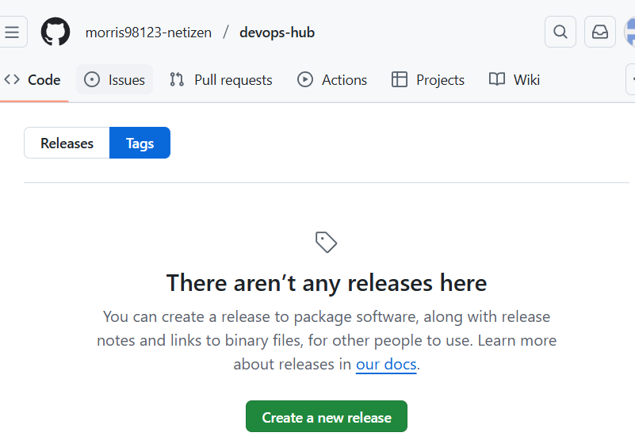
Git tag v1.0 – create a tage version
Git tag
Git push origin v1.0 – puch to repo
Go and check in repo tags
Git tag -d v1.0 - it is used to delete the version
Git tag
Git push –delete origin v1.0 – to delete the git tag
Check in repo it is relese

8. Clone with Sparse Checkout.
Git clone -no checkout <repo-ur> - clone the repo without files we use command
Cd (floder)
Git sprase-checkout init –cone _this tuen sprase mode
Git checkout master – now git downloads only the selected floder
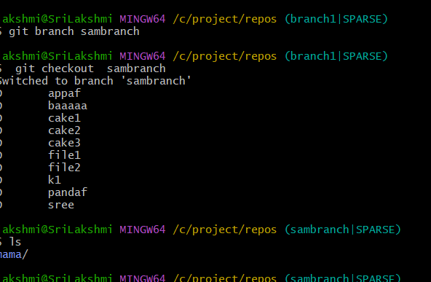

9 .Reset vs Revert Challenge
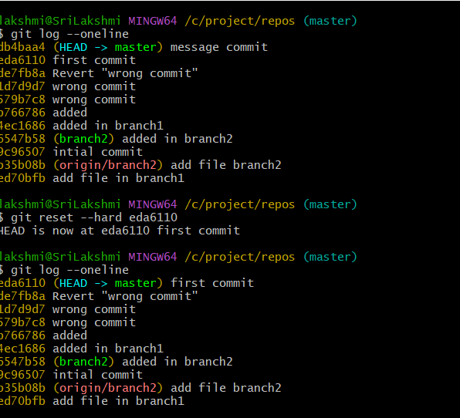
Git reste –hard – this remove commit form history and detele the file
After reset commit “message commit” disapper form history
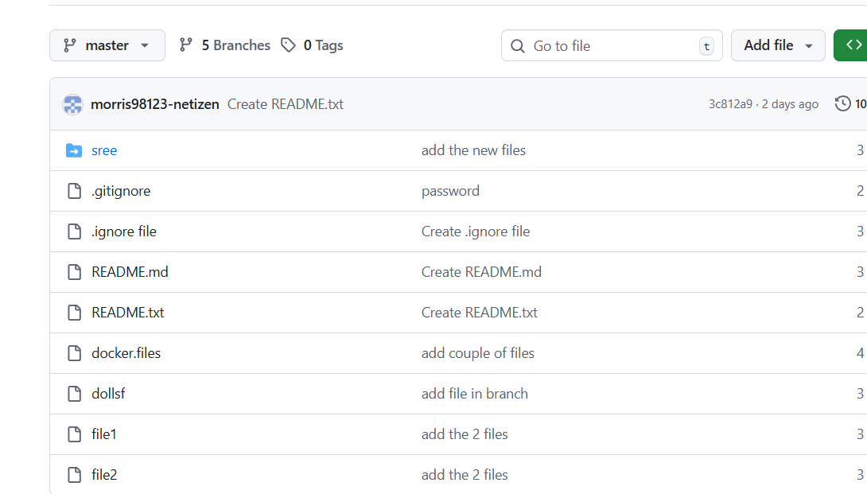
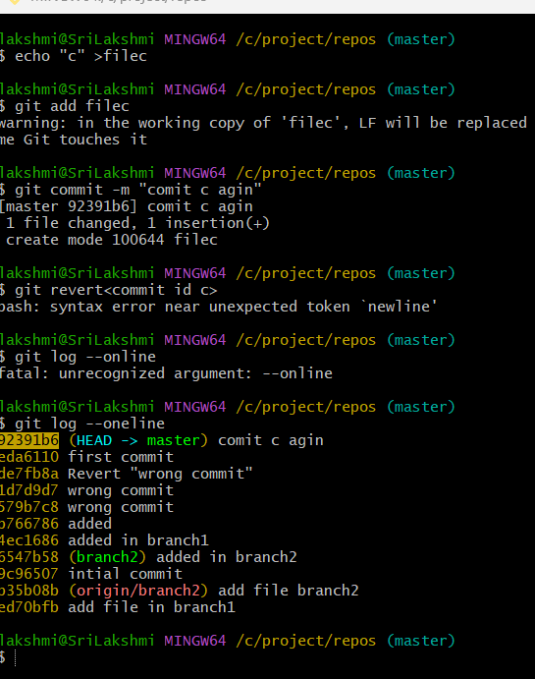
Git revert <commit id>
Git log –oneline

10. Detached HEAD Challenge
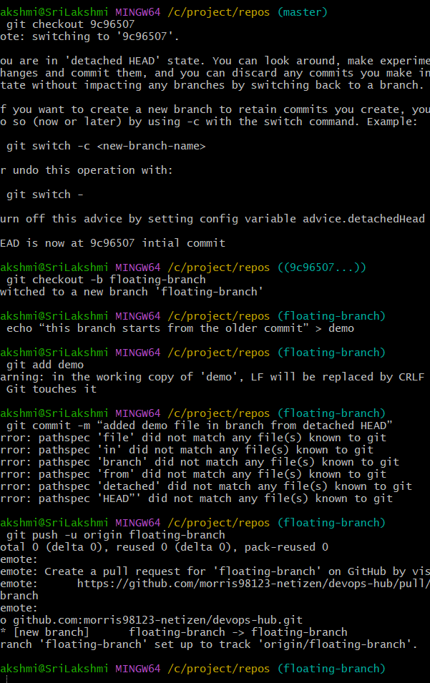
Git log –online - View your commit history use command
git checkout <commit id>
git checkout -b floating-branch
echo “this branch starts from the older commit” > demo
git add demo
git commit -m “added demo file in branch from detached HEAD”
git push -u origin floating-branch

11. Git Hooks Challenge
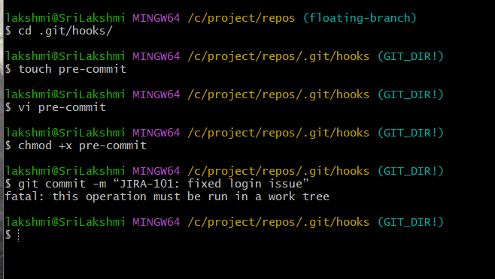
Cd <directory>
Cd.git/hooks
Touch pre-commit
#!/bin/sh
commit_msg_file=$(git rev-parse --git-dir)/COMMIT_EDITMSG
commit_msg=$(head -n 1 "$commit_msg_file")
if ! echo "$commit_msg" | grep -Eq "^JIRA-[0-9]+"; then
echo " ERROR: Commit message must start with JIRA-XXX"
exit 1
fi
chmod +x pre-commit
git commit -m “JIRA-101: fixed login issue”

12. Squash Merge vs Rebase Merge
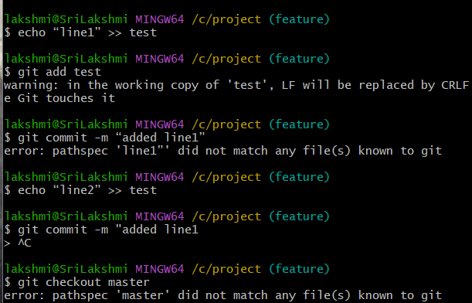
Git checkout -b feature – create a new brach
echo “line1” >> test
git add test
git commit -m “added line1”
echo “line2” >> test
git commit -m “added line 2
git checkout master
git merge –squash feature
git commit -m “added lines 1 and 2 (squashed)”

